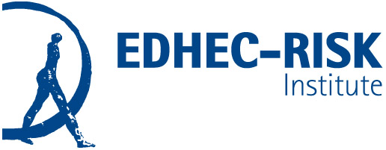

**Press Release London, Nice, Paris, 15 September 2020**

**Jaap van Dam, Principal Director of Investment Strategy at PGGM, appointed new chairman of EDHEC-Risk Institute’s international advisory board**

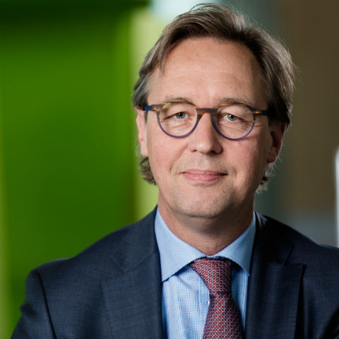EDHEC-Risk Institute is pleased to announce the appointment of Jaap van Dam as chairman of its international advisory board. He is the Principal Director of Investment Strategy at PGGM in the Netherlands. PGGM is a leading Dutch pension administrator with roots in the healthcare and social work sectors. It manages about €268 billion ($329 billion) in pension assets for more than 2.5 million Dutch participants. PGGM provides services in pension fund management, comprehensive asset management, management support, and policy advice to various pension funds.

“EDHEC-Risk Institute is extremely fortunate to have such an experienced and talented investment professional as the new chair of its board,” said Lionel Martellini, Professor of Finance, EDHEC Business School and Director of EDHEC-Risk Institute. He added, “Jaap van Dam has been a tremendously active board member for almost 10 years, and we look forward to continuing our strong working relationship with him. Jaap will bring a wealth of experience in sustainability, a perfect fit with our Institute’s increased focus on climate change and sustainable finance.”

Jaap said, “I am honoured to succeed Mark as the chairman of the International Advisory Board. EDHEC-Risk Institute is a leading force when it comes to developing sound, innovative thinking in the fields of finance and investing, whose current and future leaders it educates. Moreover, the staff of EDHEC-Risk and the board members are an exceptional group of people both in terms of knowledge and experience.”

As chairman, Jaap succeeds Mark Fawcett, Chief Investment Officer of NEST Corporation, the trustee body responsible for running NEST, the National Employment Savings Trust.

Jaap’s career in investment management spans more than three decades. He has held many roles within the industry, ranging from fundamental and quantitative analysis to external manager selection and portfolio construction. He joined PGGM in 2005 as Head of Internal Equity Management. In 2006, he was appointed Chief Strategist.

Jaap is chairman of the Dutch Association of Investors for Sustainable Development (VBDO) and the European chapter of the 300 Club. Jaap sits on the NEST (UK) Investment Committee and is a member of ICPM’s research committee. Together with Prof. Kees Koedijk and Prof. Alfred Slager, he authored *Achieving Investment Excellence: A Practical Guide for Trustees of Pension Funds, Endowments and Foundations* (2019).

The role of [EDHEC-Risk Institute’s international advisory board](http://www.edhec-risk.com/about_us/Advisory%20Board/index_html) is to consult on the relevance and goals of the research programme proposals presented by the centre’s management and to evaluate research outcomes with respect to their potential impact on industry practices. The 32 members of the board also advise on the objectives and contents of projects deriving from the expertise of the research centre.

The full list of members of EDHEC-Risk Institute’s international advisory board can be found overleaf.



**Contact:**

For more information, please contact: **Maud Gauchon**

Tel.: **+33 493 187 887** – E-mail: [maud.gauchon@edhec-risk.com](mailto:maud.gauchon@edhec-risk.com)

Visit our website: <https://risk.edhec.edu>

**Members of the EDHEC-Risk Institute Advisory Board**

**Members of EDHEC-Risk Institute’s International Advisory Board:**

* **Chairman: Mr Jaap van Dam**, Principal Director of Investment Strategy, PGGM.
* **Mr Kasper Ahrndt Lorenzen**, Chief Investment Officer, PFA Pension.
* **Mr Noël Amenc**, CEO, Scientific Beta, part of SGX group.
* **Ms Jayne Atkinson**, Chief Investment Officer, Unilever UK Pension Fund.
* **Mr Christopher Ailman**, Chief Investment Officer, CalSTRS.
* **Mr Patrick Armstrong**,Member of the Secretariat, Financial Stability Board (FSB).
* **Ms Valérie Baudson**, Member of the Executive Committee, AMUNDI.
* **Mr Stefan** **Bichsel**, Executive Board Member and Head of the Asset Management & Trading Division, BCV and former Chairman, EFAMA.
* **Mr Frédéric Bôl**, Chief Executive Officer, Swiss Life Asset Managers.
* **Mr Kevin Bong,** Director of Economics and Investment Strategy, GIC Private Limited.
* **Mr James C. Davis**, Chief Investment Officer, OPSEU Pension Trust.
* **Mr Albert De Wet**, Senior Portfolio Manager, FirstRand Group Treasury.
* **Mr Mark Fawcett**, Chief Investment Officer, NEST Corporation, past Chairman of the International Advisory Board, EDHEC-Risk Institute.
* **Mr Patrick Fenal**, Deputy Chairman, Unigestion.
* **Mr Tomas Franzén**,Former Chief Investment Strategist, Andra AP-fonden (AP2) and Founder, Franzen Advisory.
* **Mr David Iverson**, Head of Asset Allocation, the Guardians of New Zealand Superannuation Fund.
* **Mr Jean-Louis Laurens**, Independent Director and Senior Advisor.
* **Mr François-Serge Lhabitant**, Affiliate Professor, EDHEC Business School and Chief Executive Officer, Kedge Capital.
* **Ms Jacqueline Loh**, Deputy Managing Director, Monetary Authority of Singapore (MAS).
* **Mr Lionel Martellini**, Professor of Finance, Director of EDHEC-Risk Institute.
* **Mr Joseph Masri**, Head of Risk Management, General Retirement and Social Insurance Authority (GRSIA).
* **Mr Stéphane Monier**,Head of Private Client Investments, Lombard Odier.
* **Mr Gumersindo Oliveros**, Chief Executive Officer, KAUST Investment Management Company.
* **Mr Bruno de Pampelonne**, President, Tikehau Investment Management and Chairman of the Board of Governors, EDHEC Business School.
* **Mr Olivier Rousseau**,ExecutiveDirector, Fonds de Réserve pour les Retraites (French Pension Reserve Fund).
* **Mr Adiaan Ryder**,Chief Strategist, Abu Dhabi Investment Council (ADIC).
* **Ms Lisa Shalett**,Head of Investment and Portfolio Solutions, Morgan Stanley Wealth Management.
* **Mr Günther Schiendl**, Director and Chief Investment Officer, VBV-Pensionskasse.
* **Mr Anil Suri**, Managing Director, Head of Portfolio Construction & Investment Analytics, Merrill Lynch Wealth Management.
* **Mr Philippe Teilhard de Chardin**, Chief Executive Officer, Advisors and Partners.
* **Mr Brnic Van Wyk**, Head of Asset/Liability Management, Investments Division, QSuper.
* **Mr Jean-Paul Villain**, Director of the Strategy Unit, Abu Dhabi Investment Authority (ADIA).

**About EDHEC-Risk Institute**

Since 2001, EDHEC Business School has been pursuing an ambitious policy to produce academic research that is both practical and relevant. This policy, known as “Research for Business” and now labelled “Make an Impact”, aims to make EDHEC an academic institution of reference in a small number of areas in which the school has reached critical mass in terms of expertise and research results.

In 2001, EDHEC Business School created EDHEC-Risk Institute, a premier academic centre for industry-relevant research in investment management, which has developed a portfolio of research and educational initiatives in the domain of investment solutions for institutional and individual investors.

The institute, in partnership with industry leaders, boasts a team of permanent professors, engineers and support staff, as well as affiliate professors and research associates. Their collective work has a particularly significant footprint in the areas of **factor investing, retirement investing and sustainable investing.** Its philosophy is to validate its work by publishing in international academic journals, as well as to make it available to the sector through position papers, published studies, online courses, on-campus workshops and global conferences.

To ensure the dissemination of its research to the investment industry, EDHEC-Risk also provides professionals with access to its website, <https://risk.edhec.edu>, which has more than 120,000 visitors and is devoted to asset and risk management research, with a focus on investment solutions. Finally, its quarterly newsletter is distributed to over 100,000 readers.

Building on the cutting-edge research of the faculty, EDHEC-Risk Institute creates programmes to help executives level up their financial expertise on topics of considerable interest in the asset management industry: factor investing, goal-based investing, sustainable investing, data science and machine learning.

EDHEC-Risk’s mission is to give participants an edge in today’s fast-changing landscape, with programmes designed to guide them towards converting theoretical concepts into practical results. Courses are run in different formats to match the market’s needs: 100% on line, on-site, blended or bespoke programmes. To date, 2,500 professionals have chosen EDHEC-Risk Institute to help them address their challenges.

As part of its policy of transferring know-how to the investment industry, EDHEC-Risk Institute set up Scientific Beta, an original initiative to boost the take-up of the latest advances in smart beta design and implementation by the whole investment industry. On 31 January 2020, Singapore Exchange (SGX) acquired a majority stake in Scientific Beta, a transaction that vindicates the school’s “Make an Impact” model and its focus on producing research that is useful for both students and businesses.

EDHEC-Risk Institute also contributed to the launch of EDHEC Infrastructure Institute (EDHEC*infra*), a spin-off dedicated to benchmarking private infrastructure investments. EDHEC*infra* is now a provider of research and indices on unlisted infrastructure investments.

@EDHECRisk

#MakeFinanceUsefulAgain

**EDHEC-Risk Institute EDHEC-Risk Institute – Europe**

393 promenade des Anglais 10 Fleet Place, Ludgate

BP 3116 – 06202 Nice Cedex 3 London EC4M 7RB

France United Kingdom

Tel: +33 493 187 887 Tel: + 44 207 332 5600